IT RCSA Audit Documentation
Config Authentication – BSI.IT.10.C13
Design Assessment, Walkthrough and Sample of One (MIA-DC-SQLPRD01 – Windows / mia-dc-nb01-fs – Linux)
DESIGN RATING | SAMPLE | OBSERVATIONS
SATISFACTORY | MIA-DC-SQLPRD01  mia-dc-nb01-fs  FAIL (lockout duration) | 4

Control | BSI.IT.10.C13 – Config Authentication (Key, Semi-Automated, In every operation)
Review period | 07/05/2025 – 01/04/2026 (Semi-Annual); evidence captured 10/2026 – 11/2026
Open Action Driver | 005056BCA24E1FD0B4A6A1173BF00BA4 – 2025 RCSA C13 exceptions, target 09/30/2026, still open. Per RCSA Testing Procedure sec. 4.1.3 this is remediation testing, not CDA / CPA.
Walkthrough | IT RCSA (Edward Morfa) met with Ian Rojo (control owner) and [Infrastructure participants – to be confirmed] on [walkthrough date - to be confirmed]
Sample of one | MIA-DC-SQLPRD01 (Windows, new 2026 export, host name inside the file) and mia-dc-nb01-fs (RHEL, 2025 exception server, capture 11/03/2026). The MIA-DC-PRINT1 export in the C13 folder was not used: it is the 2025 file.
Evidence folder | CDA/C13_CDA_Evidence, CPA/C13_CPA_Evidence and C11 CPA/C11_CPA_Evidence E01. Start with BSI.IT.10.C13_E00_Evidence Index.xlsx.

Control description
[BSI.IT.10.C13 Config Authentication] In every operation, Infrastructure Engineering have configured strong authentication settings/policies for operating systems on premise to align with the Authentication and Authorization Standard. Exception to authentication configurations must be approved by the CISO.

How to use this document
All files sit in this control's CDA and CPA folders, named by E-number (for example C11_CPA_Evidence / E02). The E00 Evidence Index lists every file with its MD5. Each result in Section 3 names its evidence and where to look. Section 4 lists every place the sample appears. Results read: Pass (green), Fail (red), Observation / Open (amber - not an exception).

Evidence References
Ref | Evidence | Used for
CDA E01 | Authentication and Authorization Standard v13.0 (07/28/2026) | Named in the control; no server values (SUS.AAS.4.2.1.4 p.7 is for workstations)
CDA E02 | Windows Server Hardening Guide v6.0 (09/17/2026) | Rule 2.2.1 Account Lockout Duration 15, URGENT (p.157); 2.3.7.3 inactivity limit
CDA E03 | Linux RHEL Hardening Guide v3.0 (01/05/2026; file named "1.5") | Sec. 4.2 items 82–92, 4.4.3.x (p.15–16): deny 5, unlock_time 900, minlen 14, maxrepeat 3, remember 24
CDA E04 | Secure Build and Configuration Management Standard v8.0 | SUS.SBS.4.2.1.5, 4.2.1.6 (p.6)
CDA E05 | 2025 Exception form | 2025 exceptions under the AD
C11 CPA E01 | Windows security exports (5, new in 2026) | MIA-DC-SQLPRD01_SecExport.txt
CPA E01 | Windows security exports (10) in the C13 folder | 2025 files – same MD5 as the 2025 evidence; not used for 2026 results
CPA E02 | Linux pwquality captures 11/03/2026 | mia-dc-nb01-fs – 1st screenshot
CPA E03 | SEF exceptions 07/01/2025 – 07/04/2026 | Empty file (5 bytes)

1. Design Effectiveness Summary
The control design is effective. Trigger: every server build. Windows password and lockout policy come from the image and domain GPO and are re-applied at each policy refresh (CDA E02). Linux pwquality, faillock, pwhistory and login.defs values are set by the Linux admin during the build (CDA E03). InfoSec scans servers at least quarterly and any deviation needs a CISO-approved SEF exception (CDA E04, SUS.SBS.4.2.1.5–4.2.1.6).
Overall Rating: Satisfactory, with observations: (1) the control statement names the Authentication and Authorization Standard, but the server values are in the hardening guides; (2) escalation is not working for the 2025 finding – the AD is past its 09/30/2026 target, the lockout duration is still -1 on current builds and there is no CISO exception; (3) the evidence sent for the exception servers was not current (2025 Windows files) or complete (Linux); (4) the 2025 issue text calls the -1 value an "idle timeout", but it is the lockout duration. Per sec. 4.1.3 the rating is held in HERACLES until the AD closes.

2. WT Summary
IT RCSA met with Ian Rojo (control owner) and [Infrastructure participants – to be confirmed] on [walkthrough date - to be confirmed]. The owner confirmed the process is unchanged from the 06/06/2025 walkthrough.
- Windows: password policy (length 14, complexity, age 1 / 45, history 24) and lockout policy (5 attempts, duration, reset counter) are pushed by GPO; inactivity limit 900 seconds.
- Linux: pam_pwquality (minlen 14, dcredit / ucredit / lcredit / ocredit -1, maxrepeat 3), pam_faillock (deny 5, unlock_time 900), pam_pwhistory (remember 24) and login.defs are set at build.
- Deviation: needs a SEF exception approved by the CISO.
- 2025 finding: Windows account lockout duration -1 (all 10 servers); Linux maxrepeat 0. AD due 09/30/2026.
Sample of one: MIA-DC-SQLPRD01 and mia-dc-nb01-fs were checked against the guides. Results are in Section 3.
Based on the walkthrough, the control appears to be designed appropriately. For the sample, every Windows password setting meets the guide except the account lockout duration, which is still -1 with no CISO exception, so the Windows item fails. The Linux item can't be concluded because maxrepeat was not provided.

3. Sample of One – MIA-DC-SQLPRD01 (Windows) and mia-dc-nb01-fs (Linux)
Workpaper column | Value / conclusion | Evidence reference | Result
Evidence is current and tied to the server | New 2026 export (differs from 2025 files); host name MIA-DC-SQLPRD01 appears inside the file | C11 CPA E01 | Pass
Minimum password length (guide 14) | MinimumPasswordLength = 14 | C11 CPA E01, [System Access] | Pass
Complexity (guide Enabled) | PasswordComplexity = 1 | C11 CPA E01 | Pass
Minimum / maximum age (guide 1 / 45) | 1 / 45 | C11 CPA E01 | Pass
History (guide 24) | PasswordHistorySize = 24 | C11 CPA E01 | Pass
Lockout threshold (guide 5) | LockoutBadCount = 5 | C11 CPA E01; CDA E02 | Pass
Reset lockout counter (guide 1440 s) | ResetLockoutCount = 30 minutes (stricter) | C11 CPA E01; CDA E02 | Pass
Account lockout duration (guide 15 min, rule 2.2.1, URGENT) | LockoutDuration = -1 (locked until admin unlocks) – same as 2025 | C11 CPA E01; CDA E02 p.157 | Fail
Inactivity limit (guide 900 s or less, not 0) | InactivityTimeoutSecs = 900 (also 900 in 2025) | C11 CPA E01; CDA E02 2.3.7.3 | Pass
Linux complexity credits (guide -1) | mia-dc-nb01-fs: dcredit / ucredit / lcredit / ocredit = -1 (11/03/2026 12:03 PM) | CPA E02, screenshot 1 | Pass
Linux maxrepeat (guide 3) – 2025 exception | Not provided; command reads pwquality.conf only, guide uses pwquality.conf.d | CPA E02 | Open
Linux minlen, remember, deny, unlock_time | Not provided | CPA E02 | Open
"Exception ... approved by the CISO" | No SEF exception for lockout duration; SEF export empty | CPA E03 | Fail
Action Driver follow-up | Target 09/30/2026 passed; Windows remediation evidence sent was the 2025 files; no extension or escalation seen | CPA E01; CDA E05 | Fail
Conclusion: Sample MIA-DC-SQLPRD01 FAILED – account lockout duration is still -1 against the guide's 15 minutes, with no CISO-approved exception. All other Windows settings meet the guide. Sample mia-dc-nb01-fs is INCOMPLETE – the credit settings meet the guide but maxrepeat (the 2025 exception) was not provided. The AD should stay open.

4. Evidence Locator – where to find the samples
Ref | Evidence | What it shows
CDA E02 | Windows Server Hardening Guide v6.0 – rule 2.2.1 (p.157), 2.3.7.3 | Lockout duration 15 (URGENT); inactivity 900 s
CDA E03 | Linux RHEL Hardening Guide v3.0 – items 82–92 (p.15–16) | Linux values incl. maxrepeat 3
CDA E05 | 2025 Exception form | Original 2025 exceptions
C11 CPA E01 | MIA-DC-SQLPRD01_SecExport.txt – [System Access] and registry lines | Settings (Exhibit A1)
CPA E01 | 10 C13 exports – 2025 files (MD5 match to BSI.IT.10.C13.05 Windows samples.zip) | Not current; fresh exports requested
CPA E02 | C13 Linux-evidenceNov2026 – screenshot 1 | mia-dc-nb01-fs credits (Exhibit A2)
CPA E03 | SEF export | Empty
WP2 | WP2 BSI.IT.10.C13 Config Authentication 2026.xlsm – CPA tab rows 49–60 and 70–74 | Same results in workpaper form

Appendix A – Sample Evidence
Exhibit A1: MIA-DC-SQLPRD01 security export (2026) – excerpt (C11 CPA E01)
MinimumPasswordAge = 1
MaximumPasswordAge = 45
MinimumPasswordLength = 14
PasswordComplexity = 1
PasswordHistorySize = 24
LockoutBadCount = 5
ResetLockoutCount = 30
LockoutDuration = -1
MACHINE\Software\Microsoft\Windows\CurrentVersion\Policies\System\InactivityTimeoutSecs=4,900
...
SeServiceLogonRight = ... SQLServer2005SQLBrowserUser$MIA-DC-SQLPRD01 ... <- host name inside the file
Source: C11 CPA E01 – MIA-DC-SQLPRD01_SecExport.txt (secedit /export /cfg). LockoutDuration = -1 is the failing value. The last line is shortened to show the host name.
Exhibit A2: mia-dc-nb01-fs – pwquality credit settings (CPA E02)
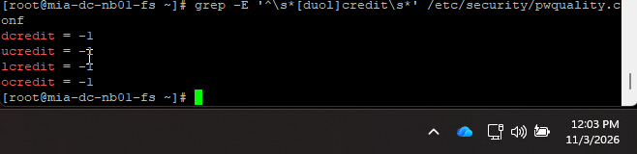
Source: CPA E02 – C13 Linux-evidenceNov2026.docx, screenshot 1. Screen clock 11/03/2026 12:03 PM. maxrepeat is not shown.
Exhibit A3: Other Linux captures received (CPA E02)
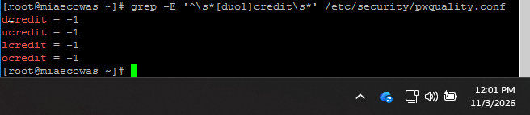
Figure A3-1. miaecowas – credit settings only (11/03/2026).
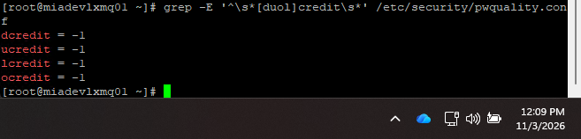
Figure A3-2. miadevlxmq01 – credit settings only (11/03/2026).
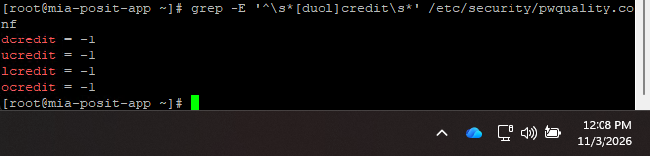
Figure A3-3. mia-posit-app – credit settings only (11/03/2026).
Exhibit A4: Why the C13-folder Windows exports were not used
File (C13 folder) | MD5 | 2025 evidence
security-export_MIADEVRDSGW01.txt | 3412a5364648a44761191aecd88fa9f7 | Same file – BSI.IT.10.C13.05 Windows samples.zip (06/25/2025)
security_exportMIA-DC-PRINT1.txt | 43f23f13e2f40232f37574c033102877 | Same file – BSI.IT.10.C13.05 Windows samples.zip (06/25/2025)
security_export_MIA-DC-SNOWMID1.txt | 76689b27230f86c63b404ce74497fe73 | Same file – BSI.IT.10.C13.05 Windows samples.zip (06/25/2025)
security_export_MIA-DC-SQL3.txt | 129aac879597678e9408a0440e13736e | Same file – BSI.IT.10.C13.05 Windows samples.zip (06/25/2025)
security_export_MIA-DC-SWDB.txt | 6a7ab66e1bae8c73646e7a78209686e5 | Same file – BSI.IT.10.C13.05 Windows samples.zip (06/25/2025)
security_export_MIA-DC-TOFS.txt | 33159cc09ab9038fef1918ddc5578533 | Same file – BSI.IT.10.C13.05 Windows samples.zip (06/25/2025)
security_export_MIA-DC-WEBIIS.txt | a6922104a00ccee6ce957d1e620789f5 | Same file – BSI.IT.10.C13.05 Windows samples.zip (06/25/2025)
security_export_MIA-HQ-FNAPP.txt | bdf05be81de7a59e93825b4a4c5ffe07 | Same file – BSI.IT.10.C13.05 Windows samples.zip (06/25/2025)
security_export_MIADCCTXLIC01.txt | 33159cc09ab9038fef1918ddc5578533 | Same file – BSI.IT.10.C13.05 Windows samples.zip (06/25/2025)
security_export_MIADCRDSTABLEAU.txt | c0ae0f05d89128b79ebd24df79dd2241 | Same file – BSI.IT.10.C13.05 Windows samples.zip (06/25/2025)
Package: CDA and CPA evidence folders, E00 index, WP2 2026 workbook and this document.

